**DIY Soundboard Workshop Fall 2023**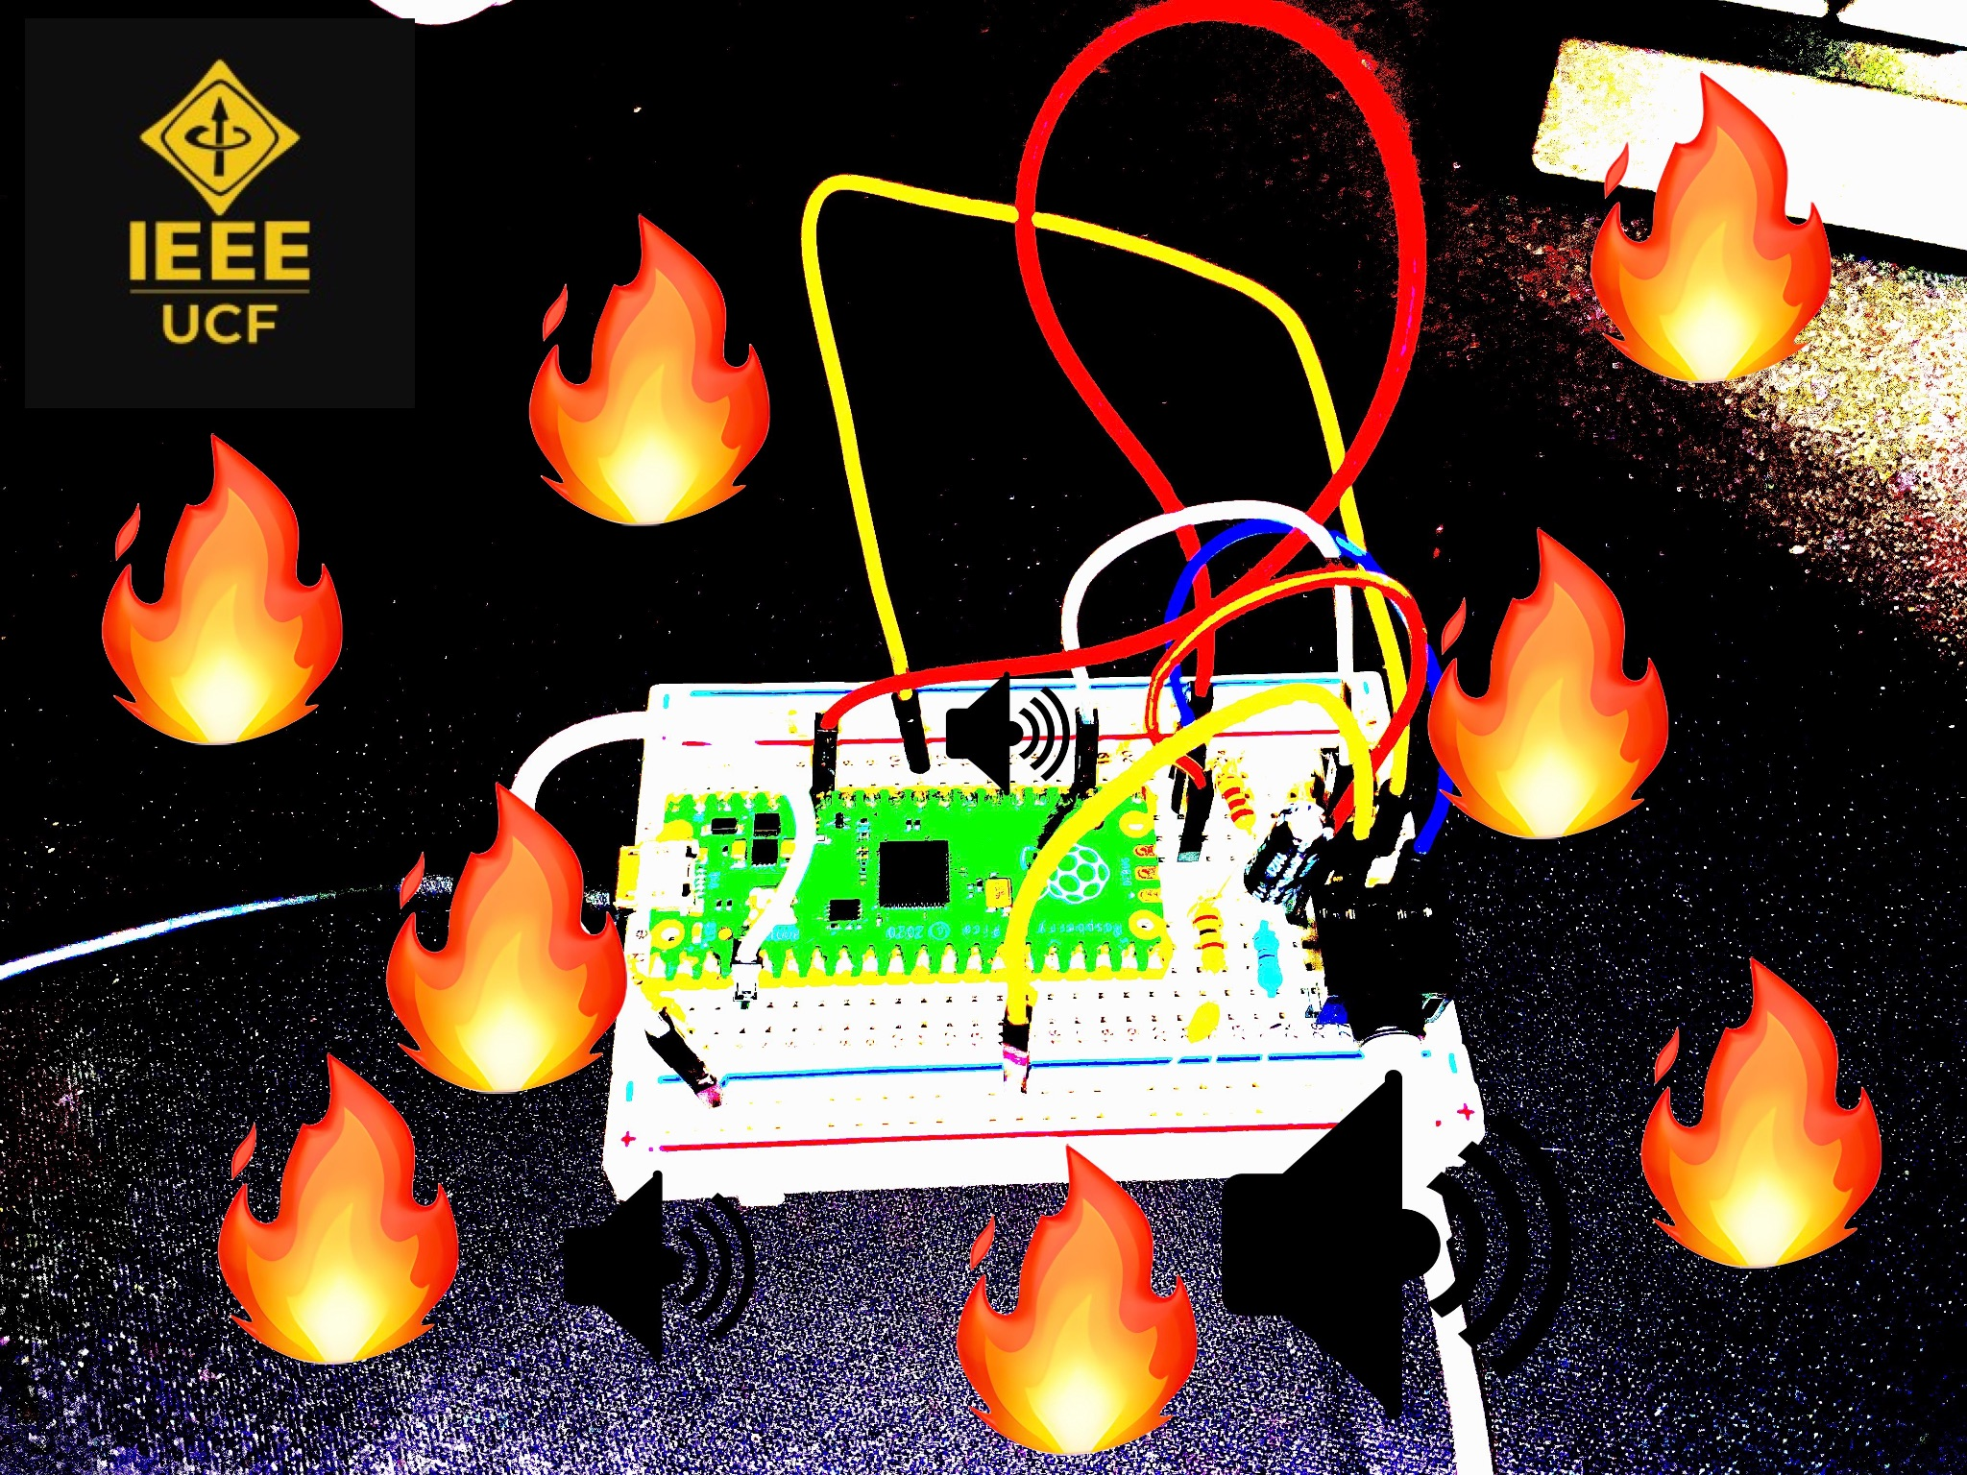

**Hardware:**

First, check to make sure everything is in your bag:

* (1) Breadboard
* (1) Raspberry Pi Pico
* (1) Micro USB Cable
* (1) Speaker
* (1) Push Button
* (1) 3.5mm Stereo Audio Out Jack
* (3) Resistors
  + (1) 100 Ohm Resistor
  + (1) 220 Ohm Resistor
  + (1) 2.2k Ohm Resistor
* (2) Capacitors
  + (1) 0.1uF Ceramic Capacitor
  + (1) 47uF Electrolytic Capacitor
* (7) Male-to-Male Jumper Wires

**Breadboarding:**

1. Take out your **breadboard**. Take note of the letters at the top and bottom, and numbers on the sides.

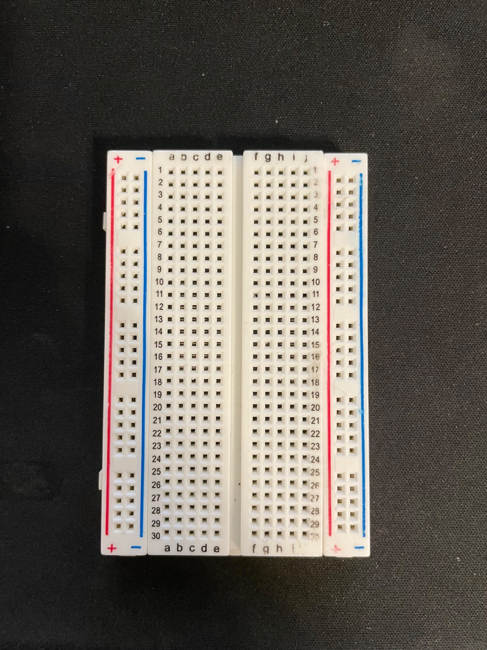

1. Connect the **audio jack** on the board so that the **middle pin** is connected to **A28**, and the other 4 pins are on the C column.

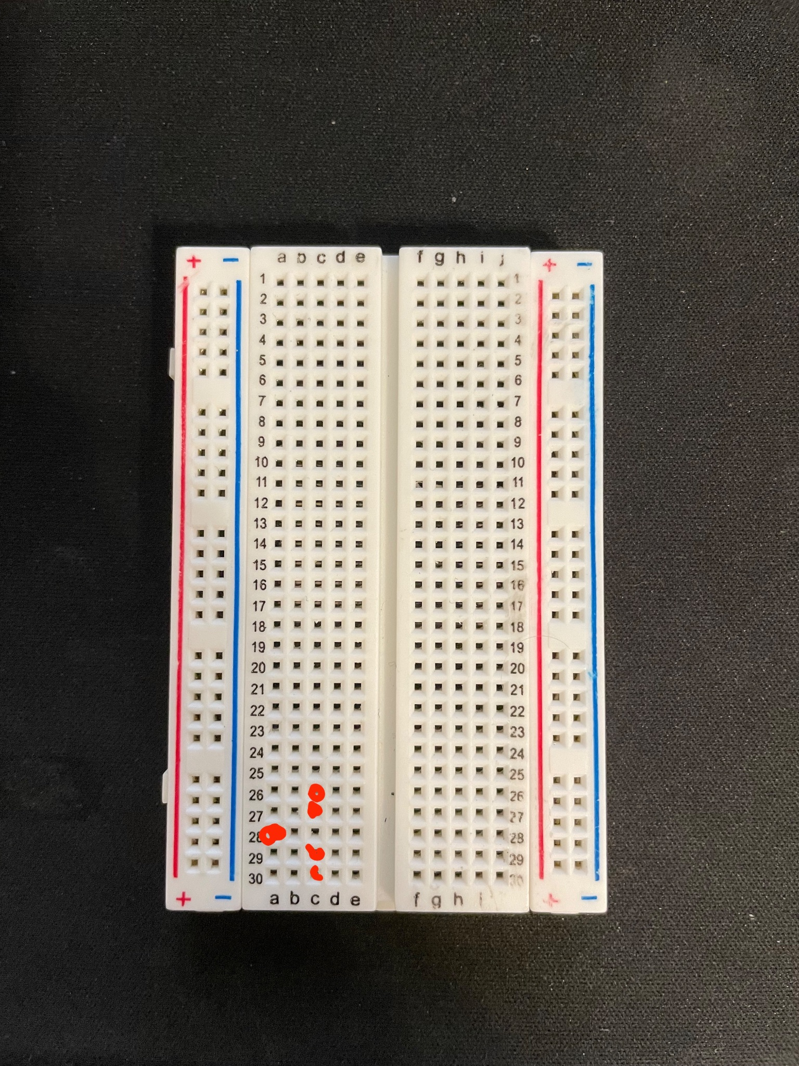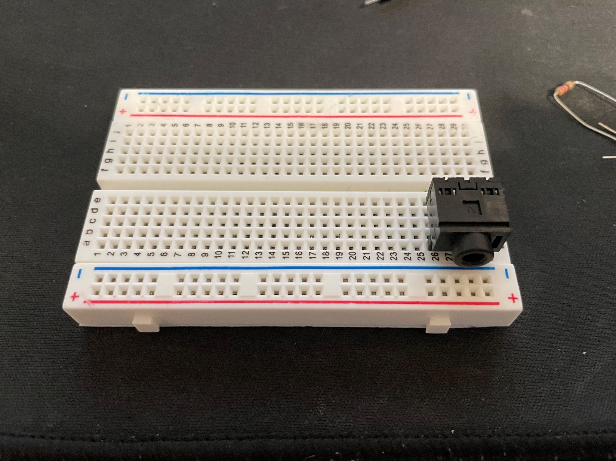

1. Take the **2.2k** ohm resistor. Place one side on **A24**, and the other to **ground**. Your resistor will look like this (Red Red Red):

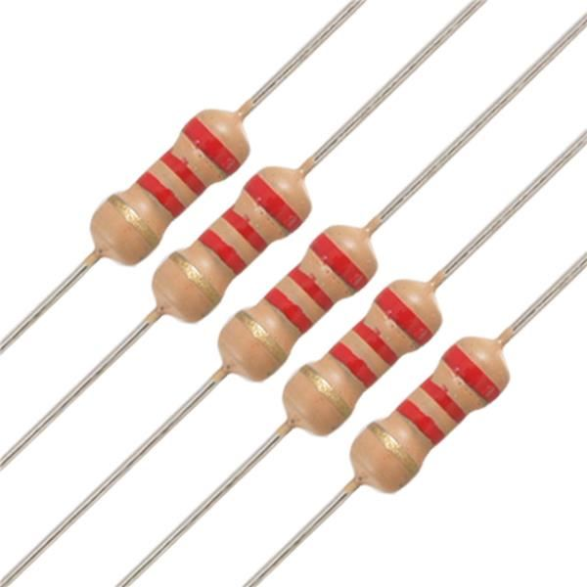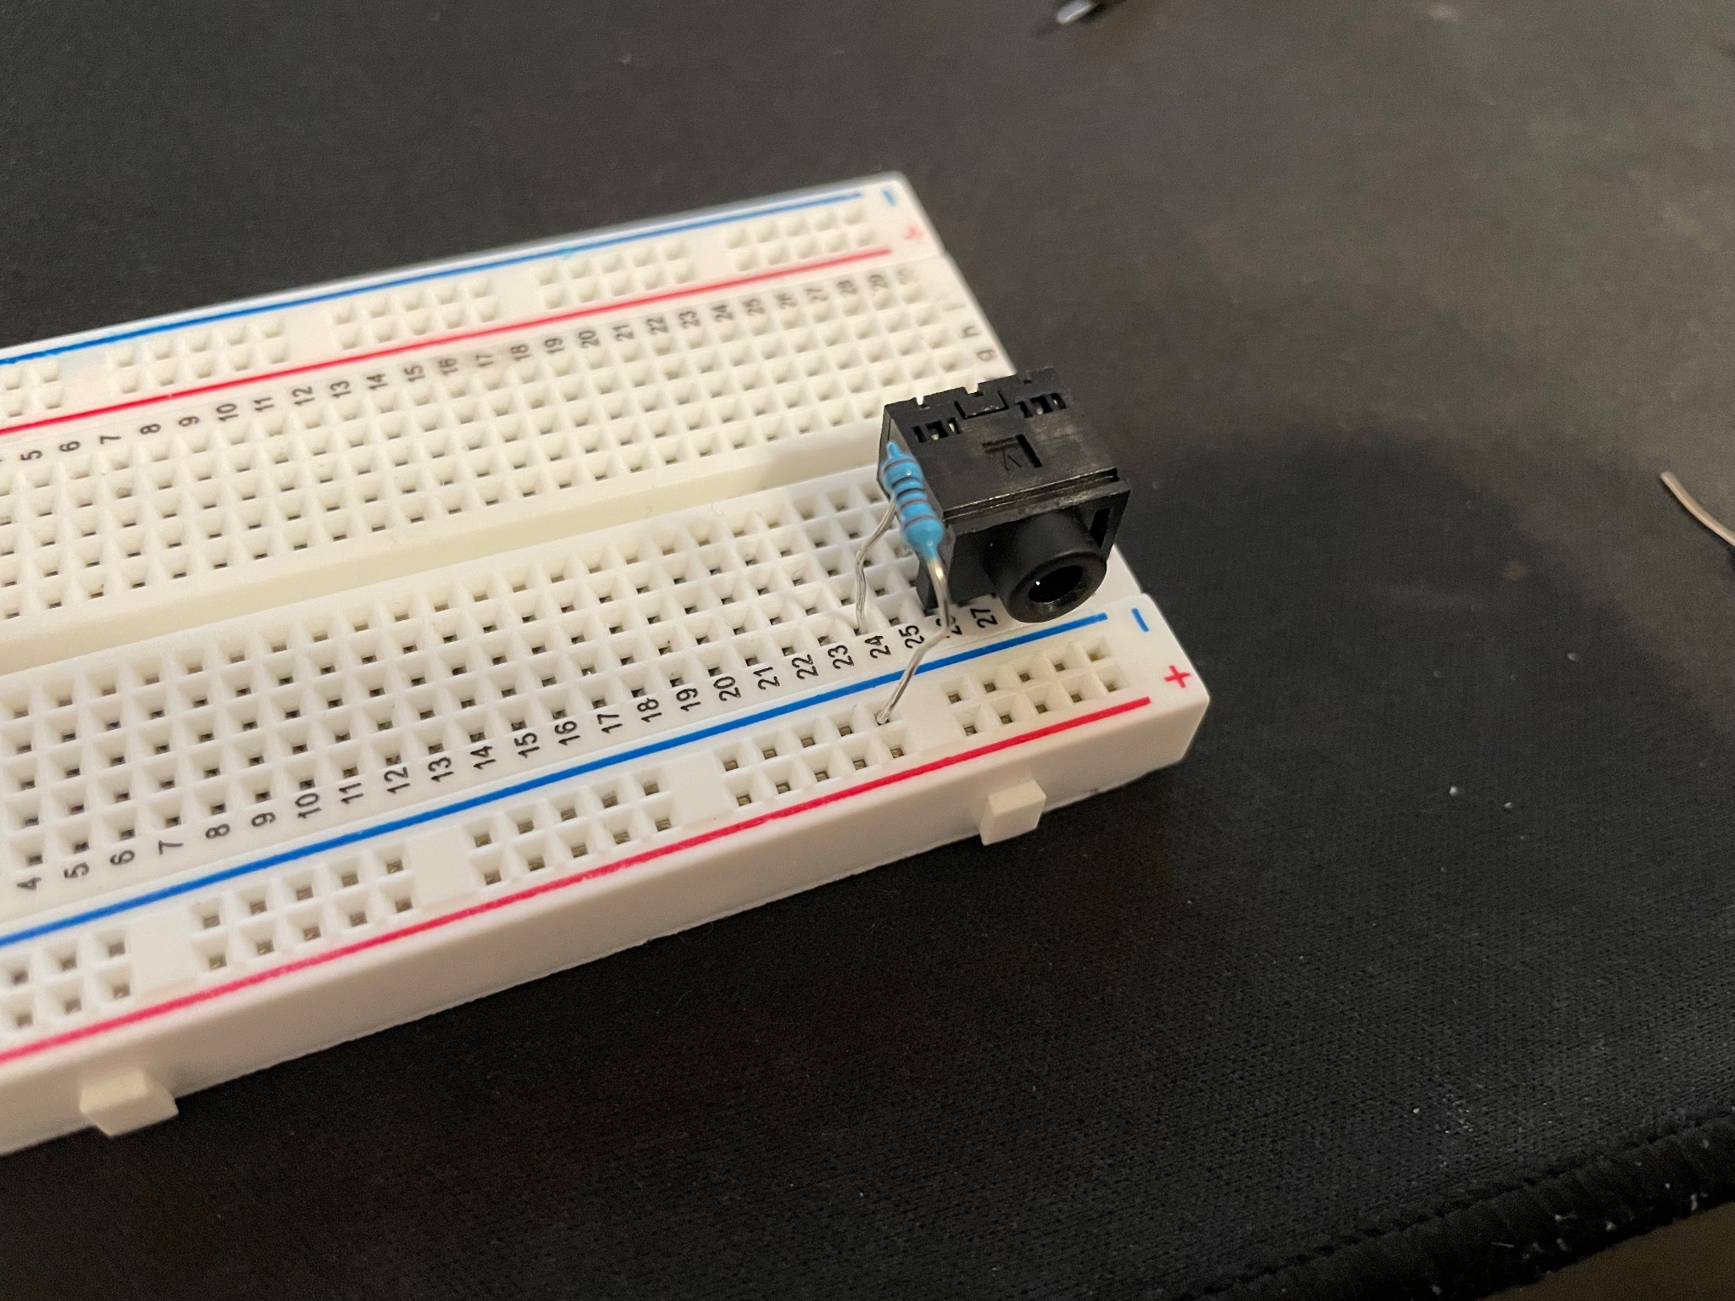

1. Connect the **0.1uF** capacitor from **A22** to **ground**. This acts as the first component for the low pass filter. Then connect the 100 ohm resistor (Brown Black Brown) from B22 to ground. This resistor acts as a voltage divider for the rest of the circuit.

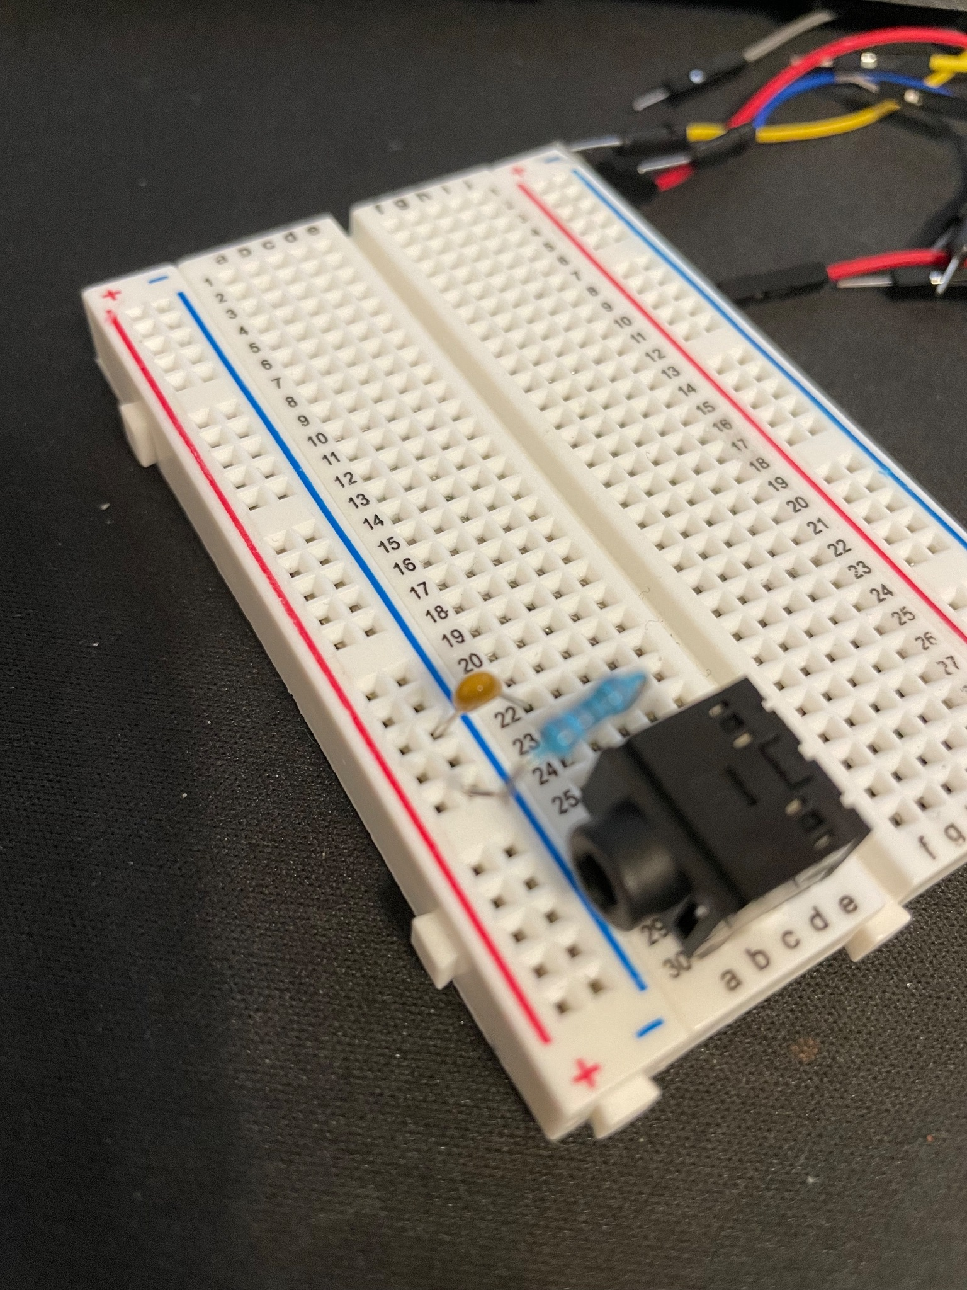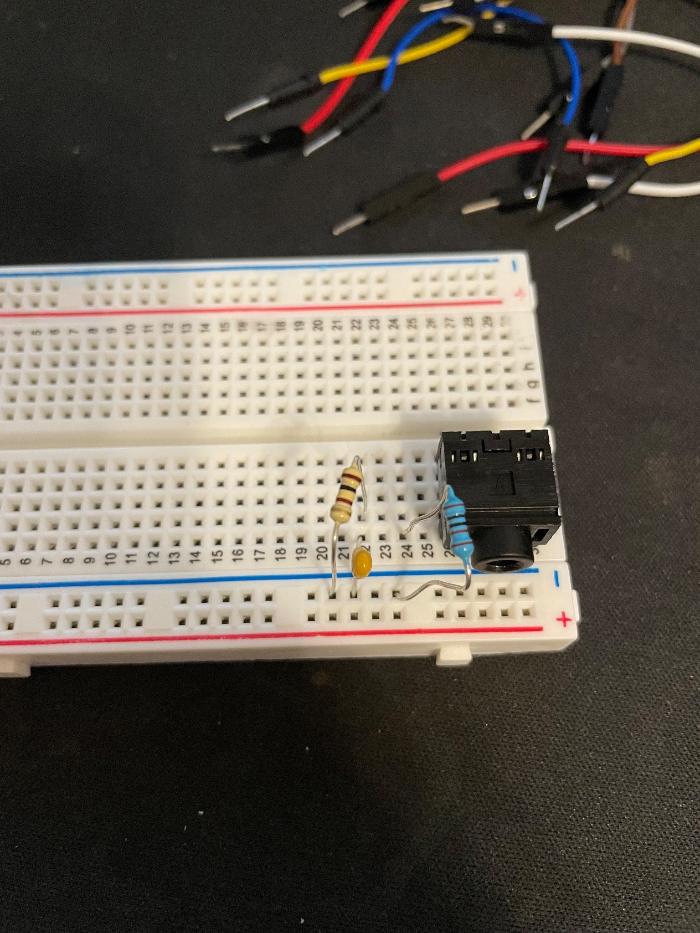

1. Connect the **47uF** capacitor so that the **positive** (longer) **leg** is on **C22** and the other leg is connected to **B24**. This capacitor couples the audio signal into the audible frequency range. Then connect the **220** ohm resistor (Red Red Brown) from **E22** to **F22**. This resistor is the other component for the low pass filter.

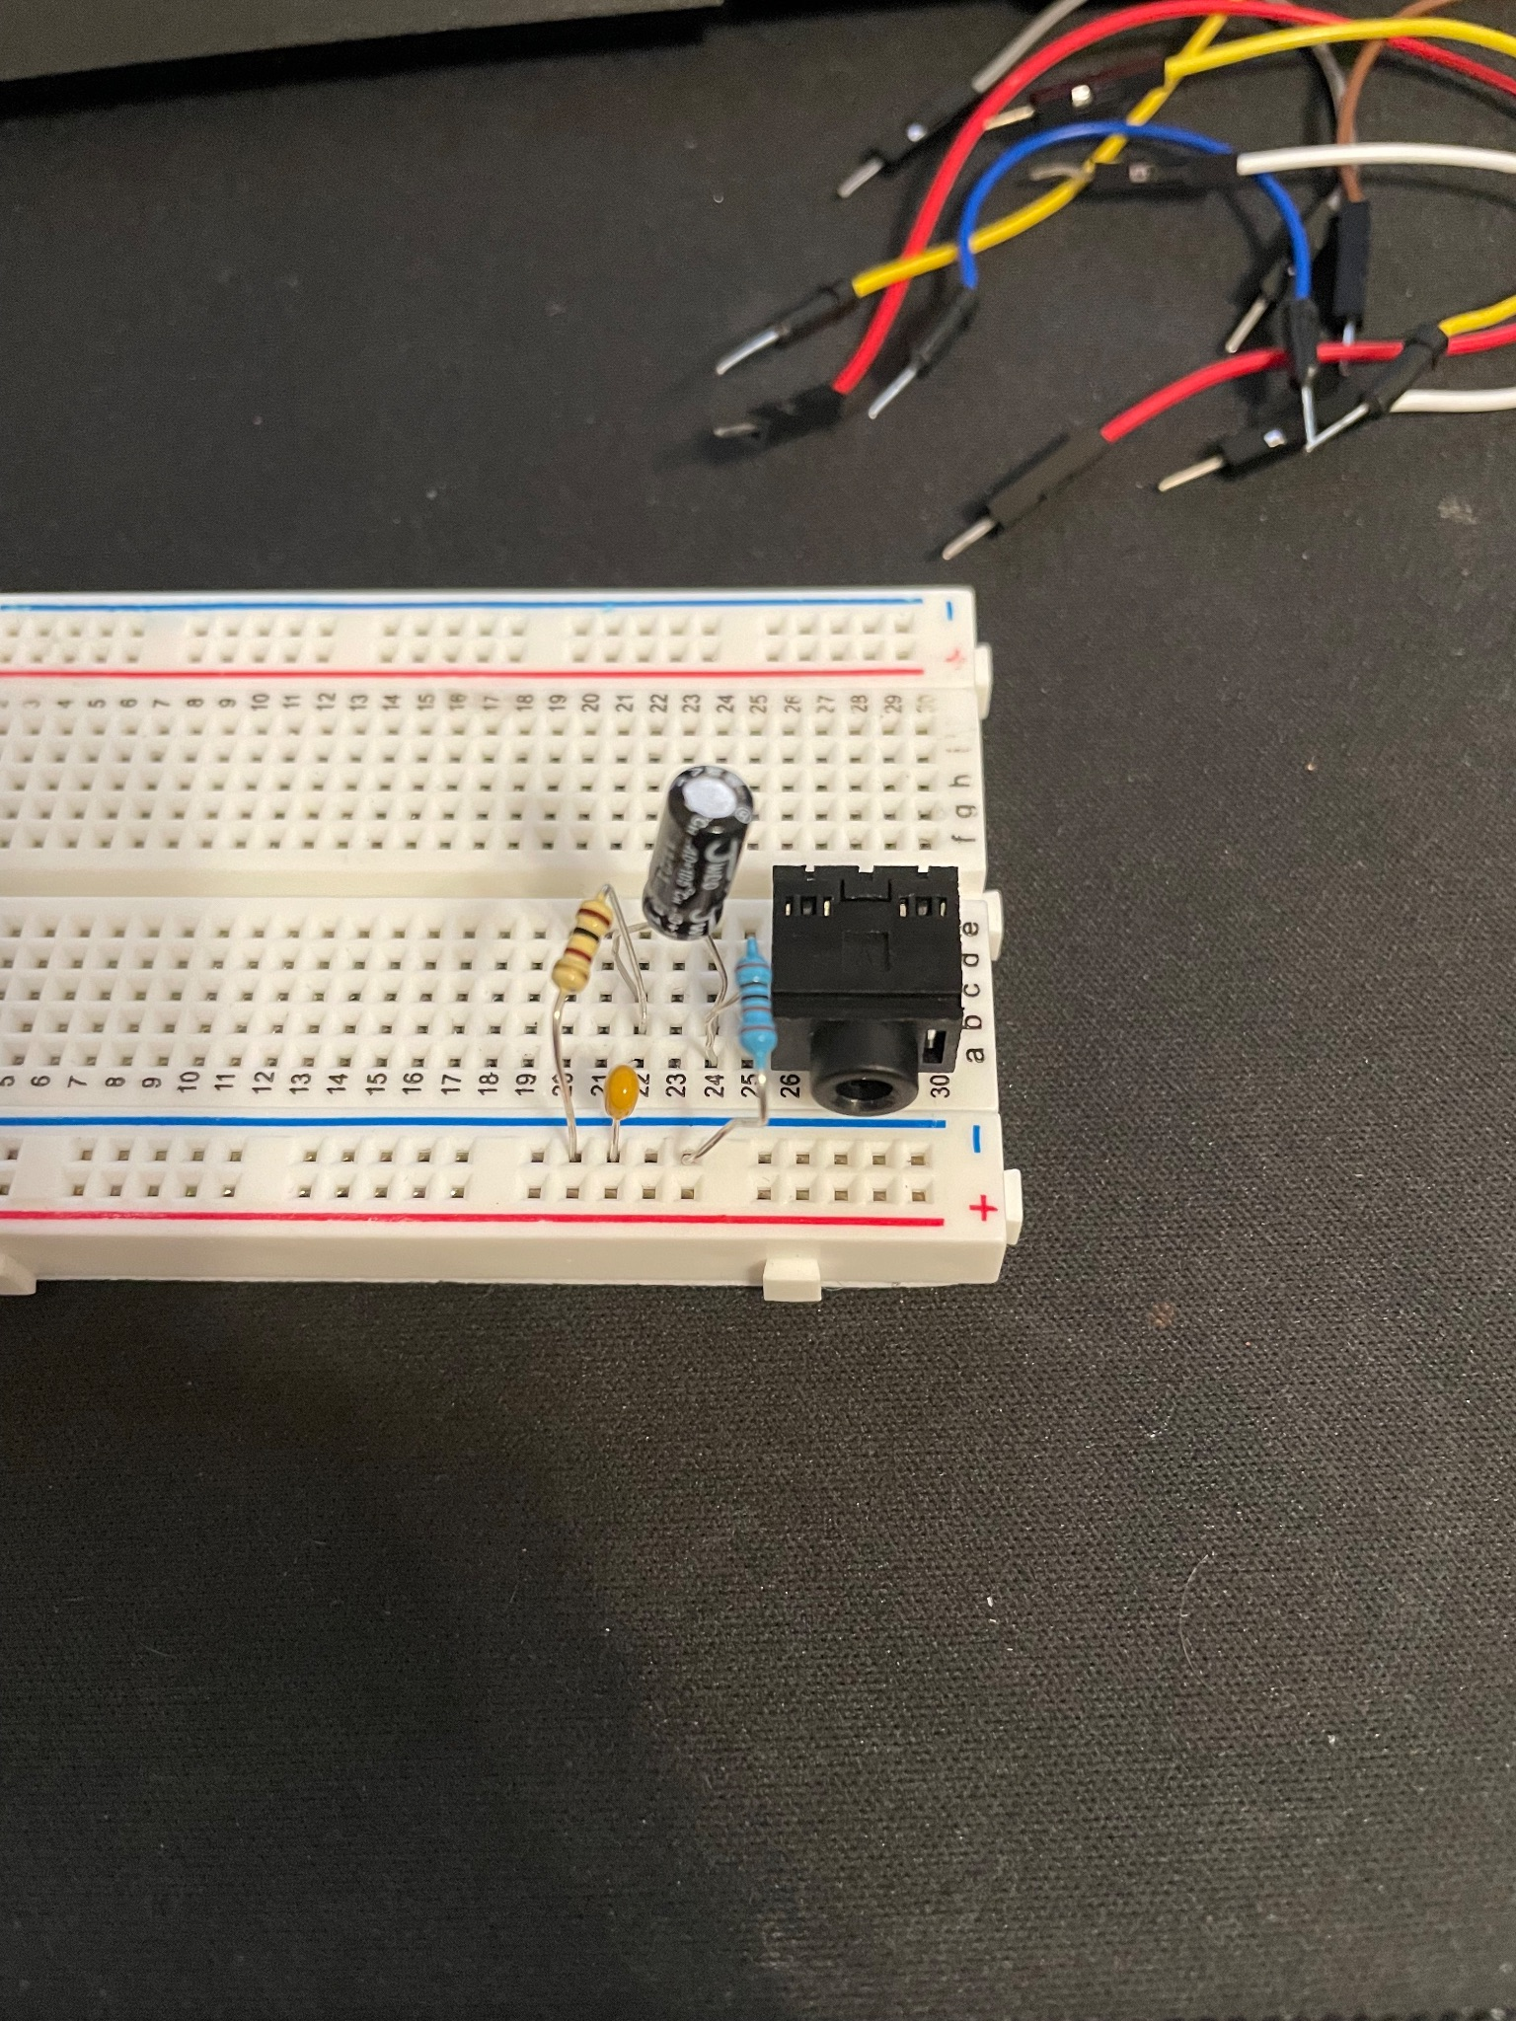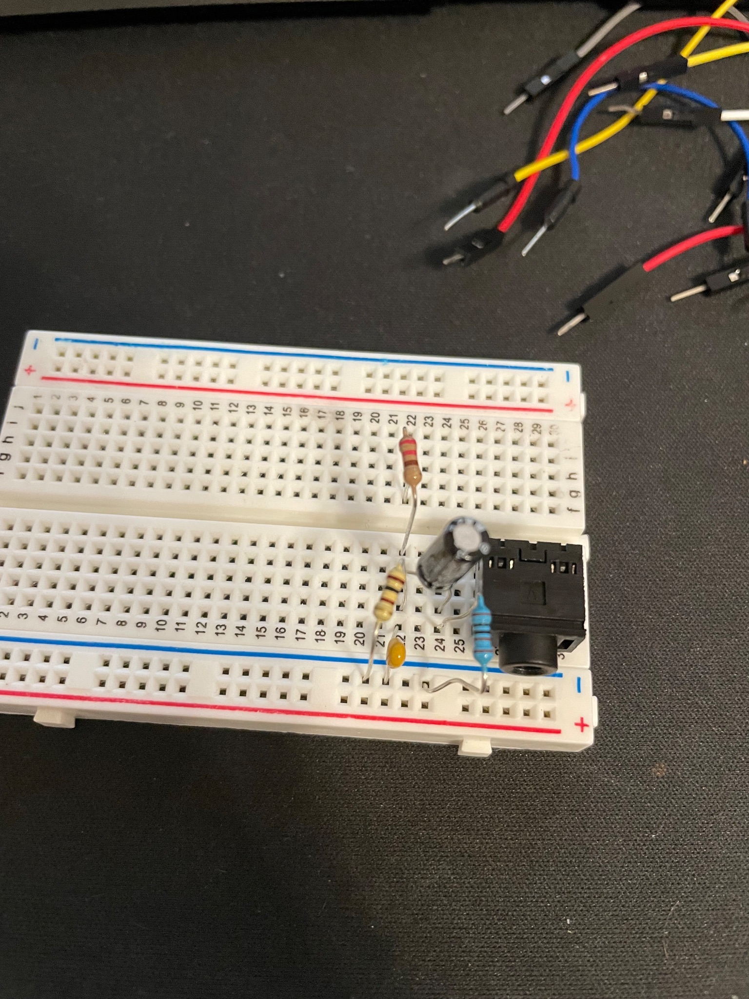

1. Take note of how the button has lines on the bottom. Use these lines as a guide to connect the pins to the board. Connect **1** to **J28**, **2** to **H28**, **3** to **J30**, and **4** to **H30**.

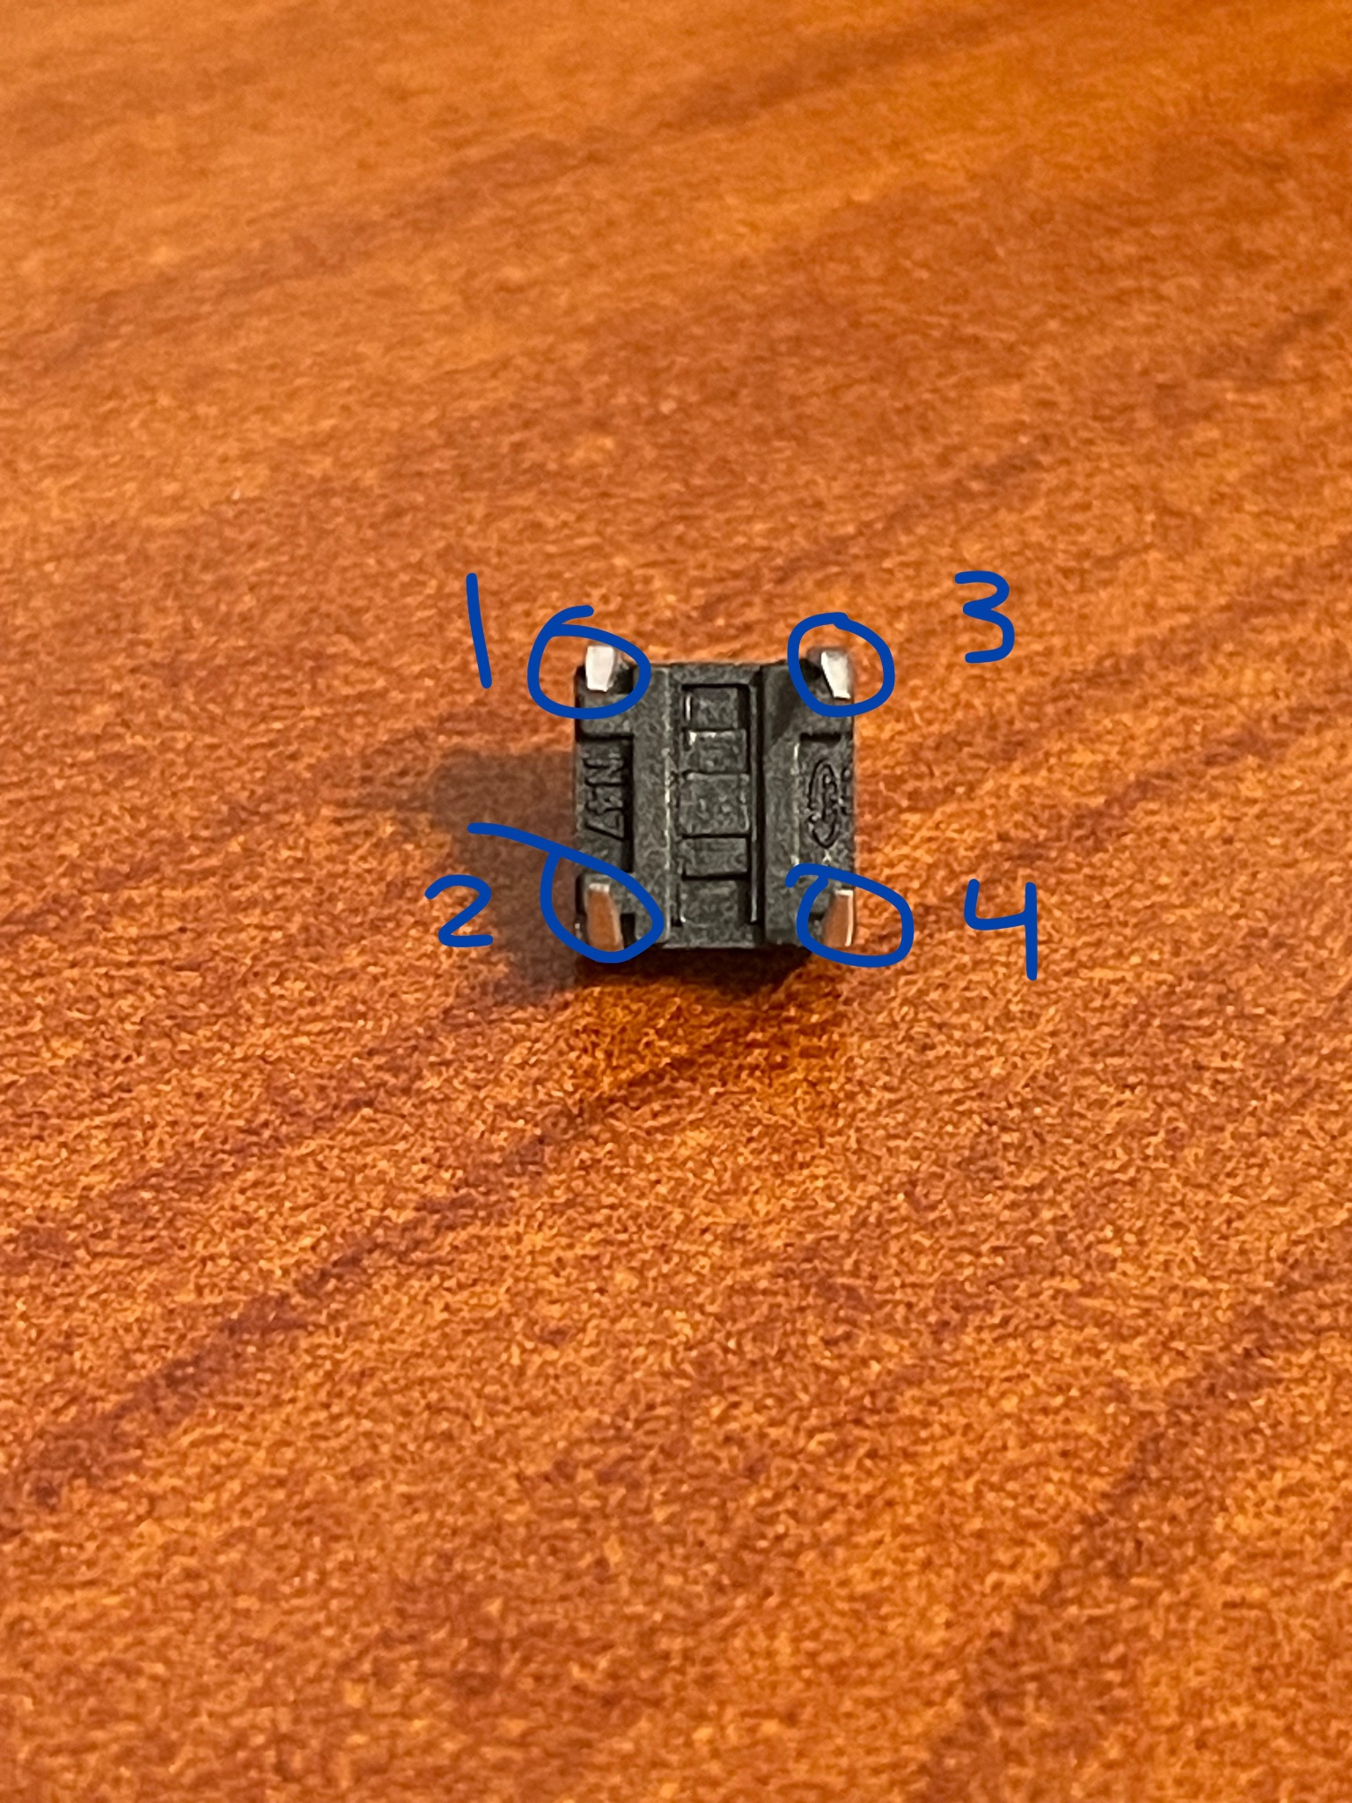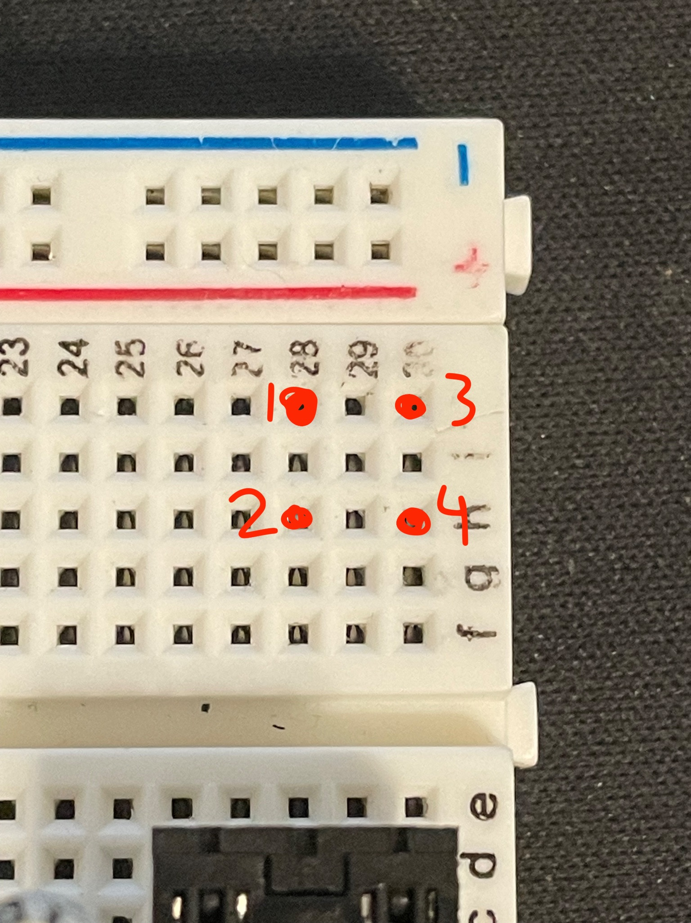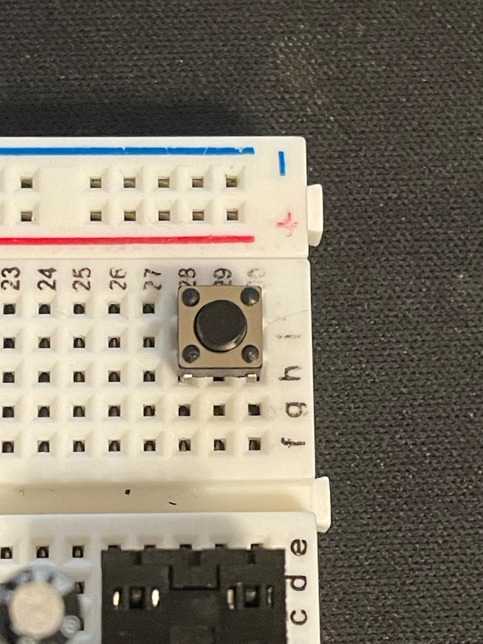

1. Take the 7 wires and connect them the following way.

* **F30** to **ground**
* **A3** (GND) to **ground**
* **E28** to **ground**
* **E30** to **D24**
* **E24** to **E26**
* **A11**(RUN) to **F28**
* **A7** (GP28) to **J22**

Make sure you **DO** **NOT** connect the Raspberry Pi to the breadboard yet!

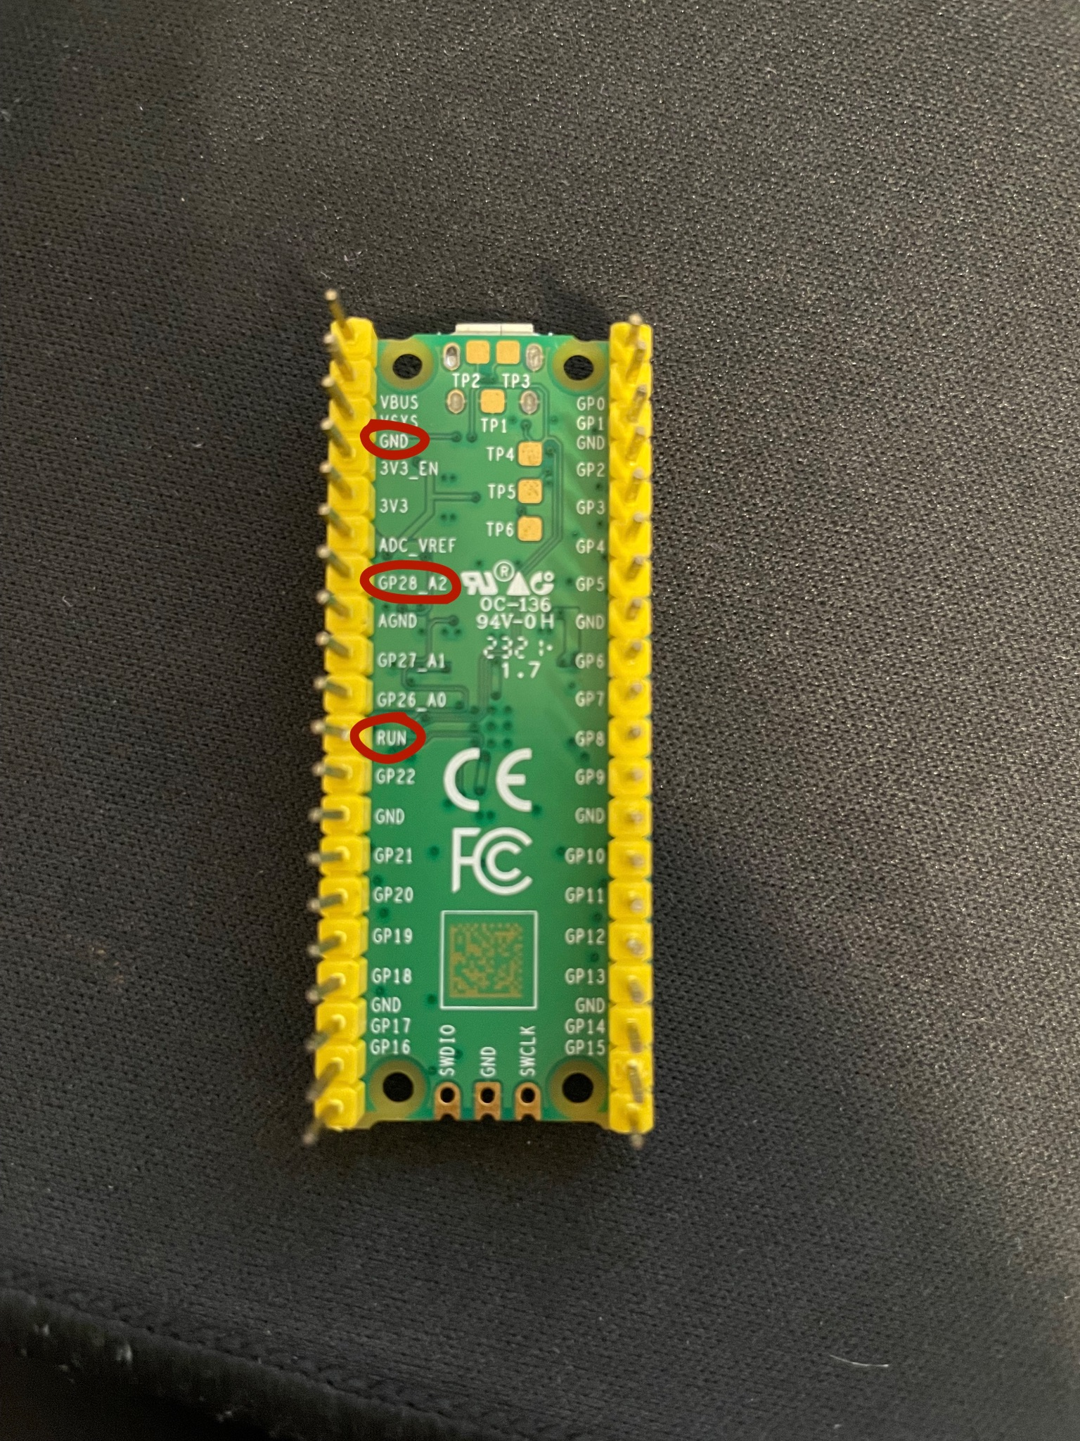

Now that you’ve set up your breadboard, open up your laptop.

**Software**:

1. **Download Arduino IDE** if you don’t already have it. <https://www.arduino.cc/en/software>
2. After installing Arduino, go to **settings**. In settings, you’ll want to click the blue button next to Additional boards manager URLs. Here you will want to **copy and paste** this GitHub link:

https://github.com/earlephilhower/arduino-pico/releases/download/global/package_rp2040_index.json

This will allow the IDE to find a board in the board manager for the Pico.

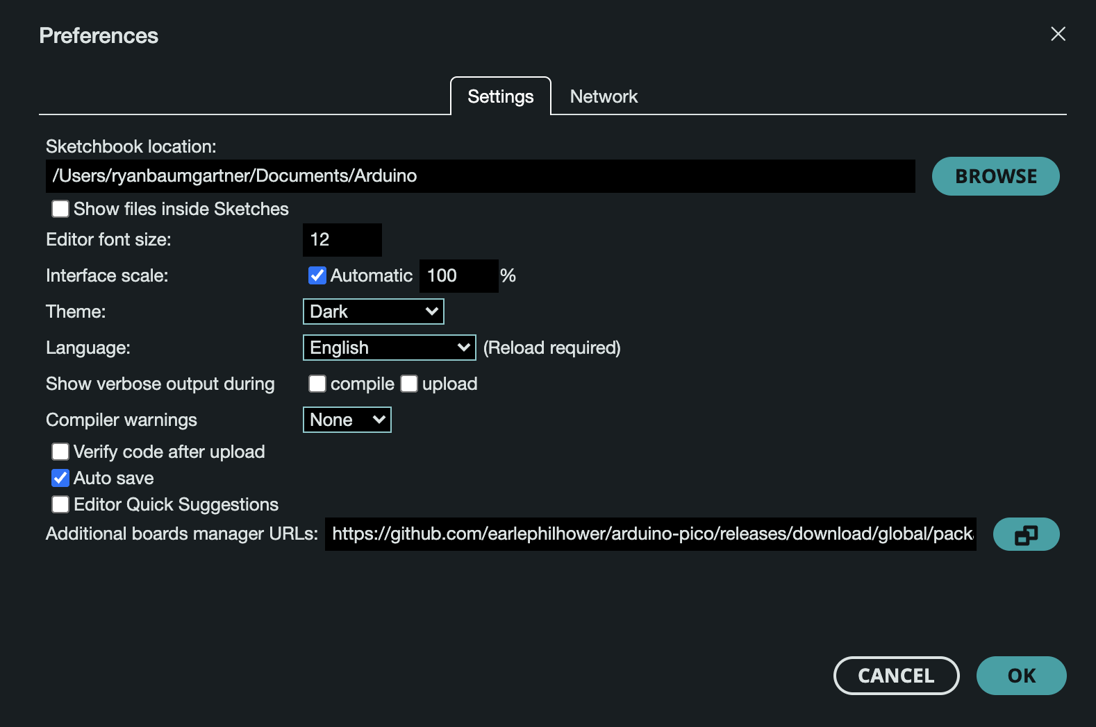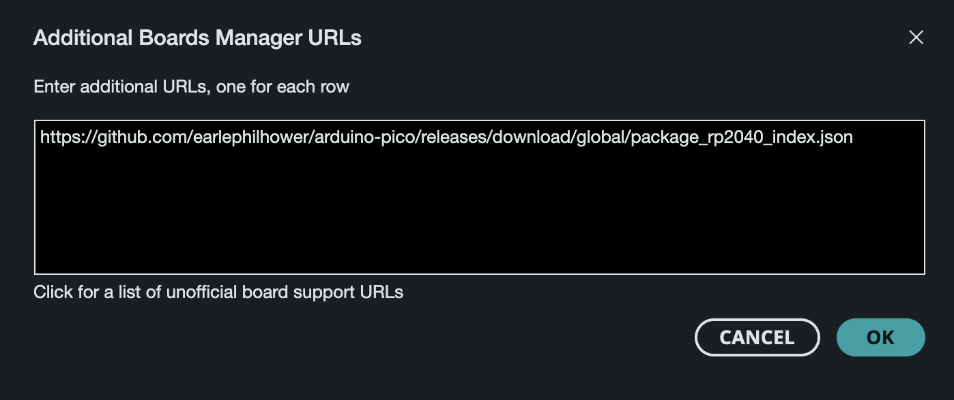

When you’re done, click OK.

1. Now go to Board Manager. This can be done either be clicking the **Board Manager** icon on the left, or by going to Tools>Board>Board Manager

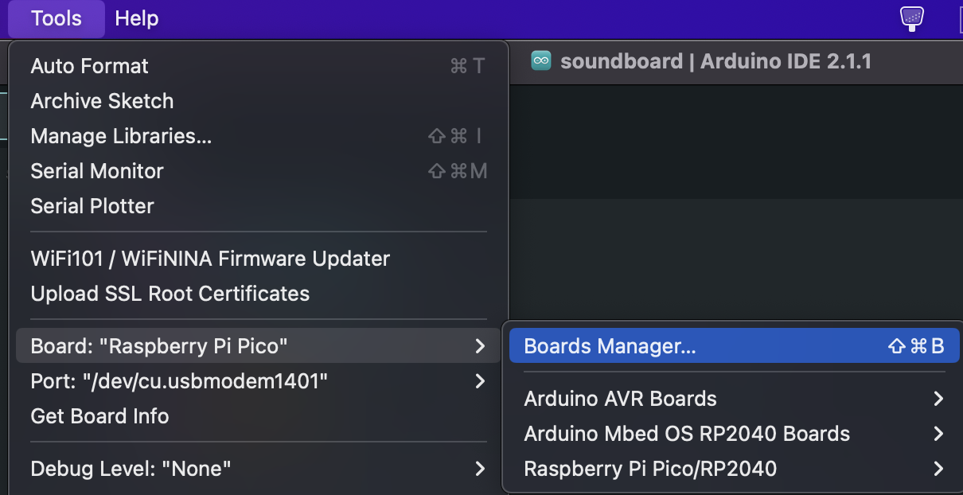

In the **search bar,** typein **Pico**. You should see an option for Raspberry Pi Pico/RP2040 by Earle F. Philhower, III. This is used so Arduino can recognize our Pico board. Click **Install**.

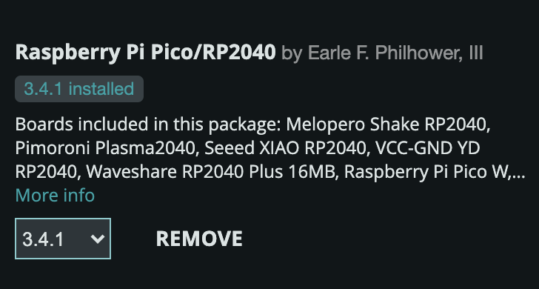

1. Now that you have Arduino up and running, go to the **Google drive** and download the Arduino code. It is labeled as “soundboard.ino”. **Open the code**. The program should look like the following

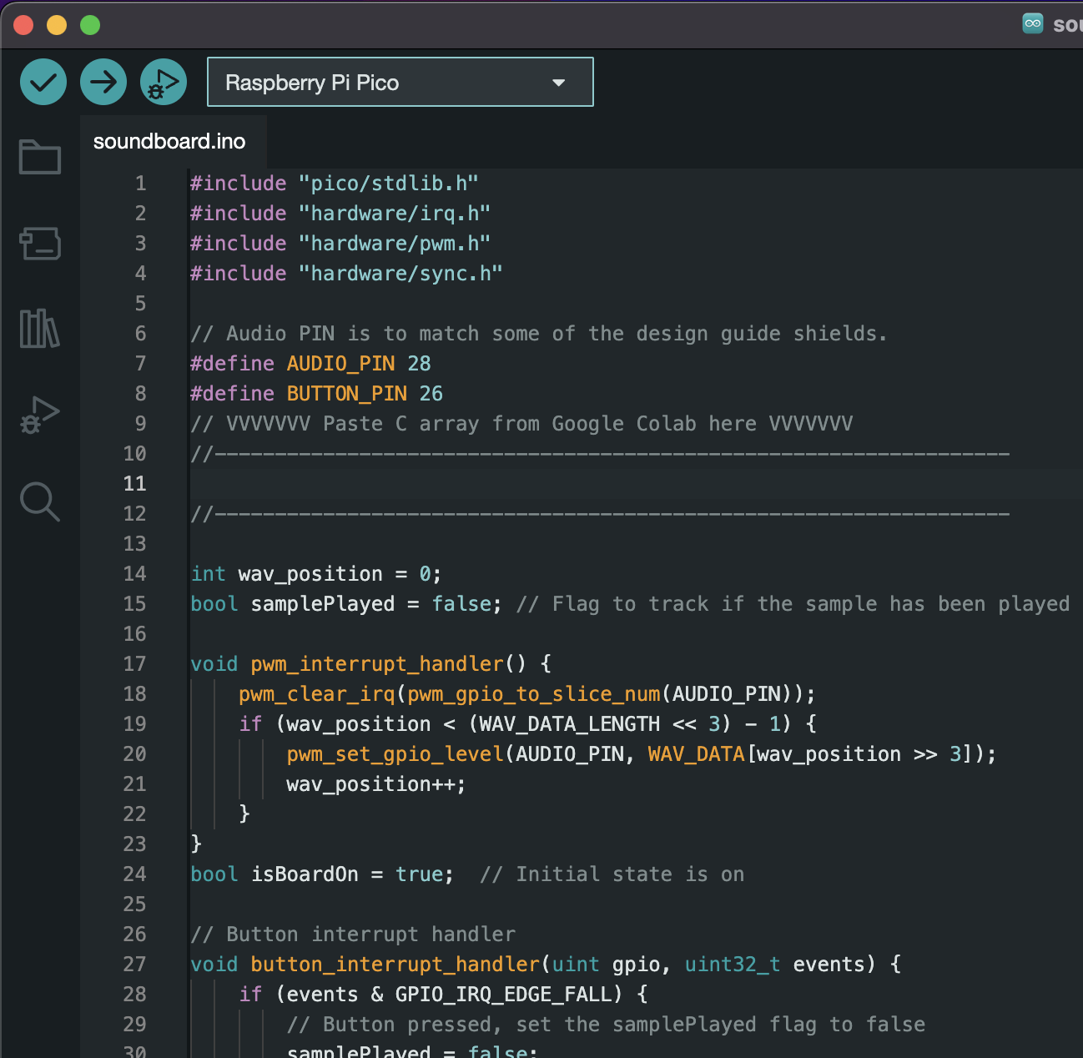

1. To play a sound file on the Pico, the audio must be converted from a .WAV file to an array of integers.

Don’t have any .WAV files? Use the following links:

Youtube to .WAV converter: <https://4kdownload.to/en1/youtube-wav-downloader>

Free WAV library: <https://bigsoundbank.com/>

Record with computer mic: <https://products.aspose.app/audio/voice-recorder/wav>

Now that you have a file, go back to the **Google Drive**, and click on the **Google Collab** document named “**Convert .WAV to Integer Array**”. Follow the instructions there, and copy the final output. It should look something like this:

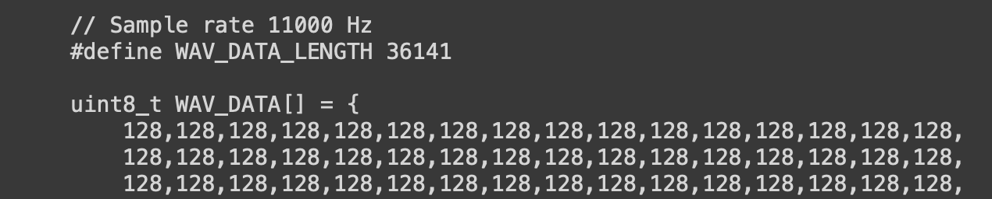

**Paste** all of the code in the Arduino program where specified.

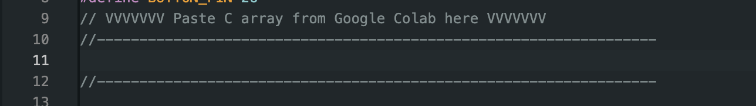

1. Go to **Tools>Board>Raspberry Pi Pico/RP2040>Raspberry Pi Pico**. This selects which board you would like to use.

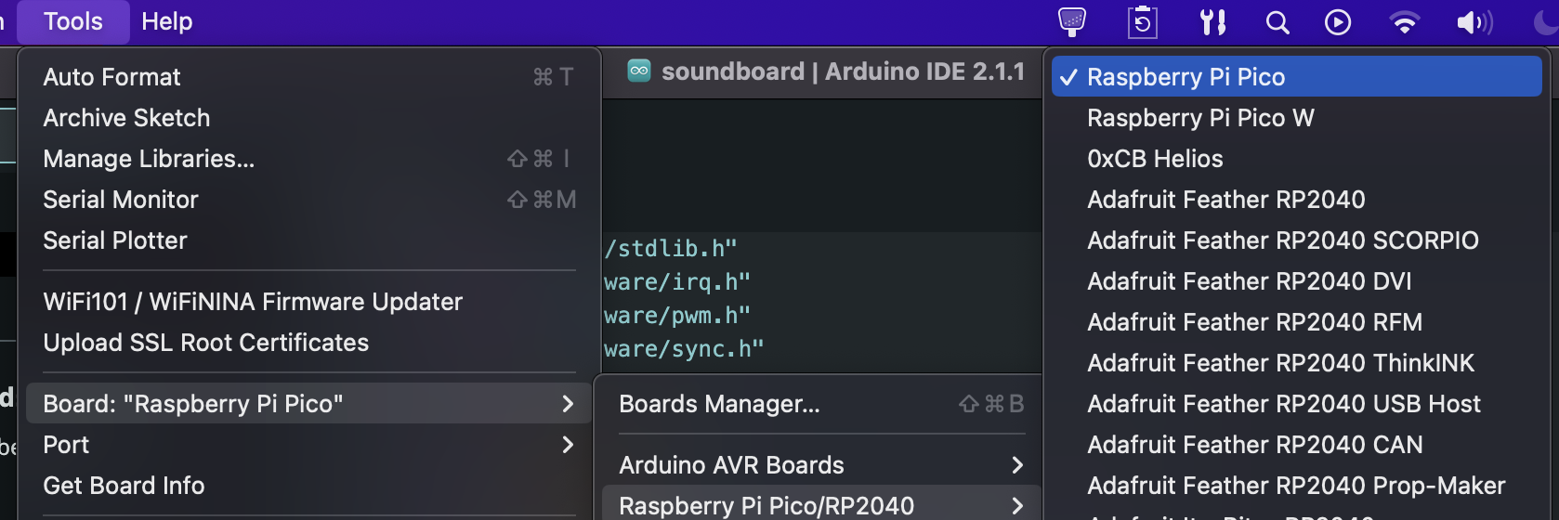

Plug in your MicroUSB cable to your laptop. On your Raspberry Pi, hold down the **BOOTSEL button** as you plug in the MicroUSB cable to the board. Let go once it's plugged in. Go to **Tools>Port>UF2 Board**. This is a temporary port that we will use while the code is being uploaded for the first time. If it doesn’t show up, you may need to do this again.

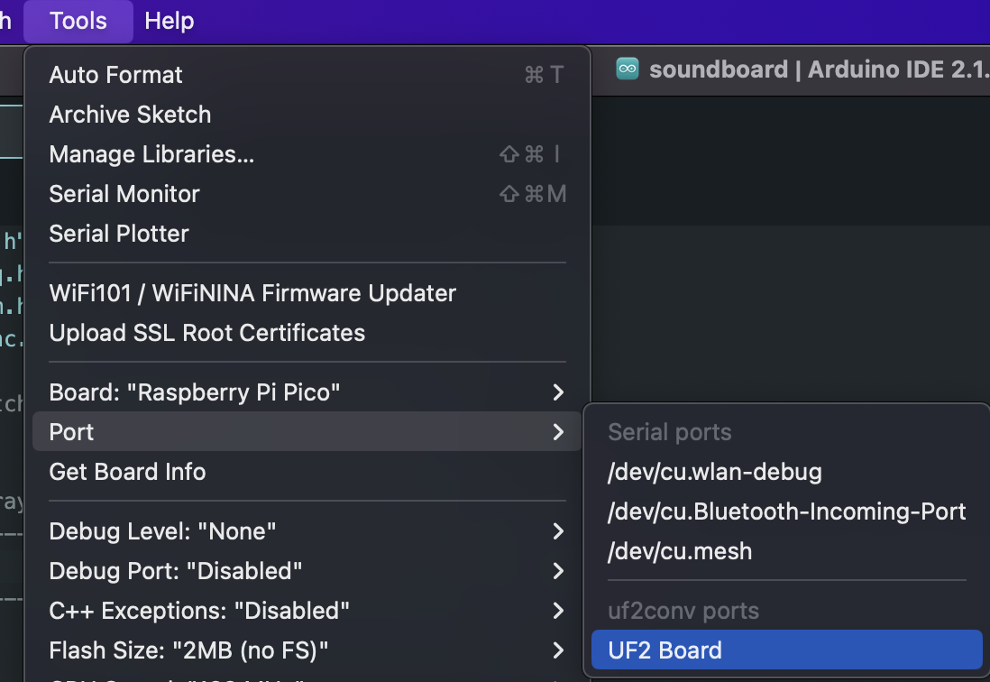

1. Click the upload button at the top. If everything works, there should be no error messages! Make sure to also change the Port to the new one that was created. You should be able to continue using this port.

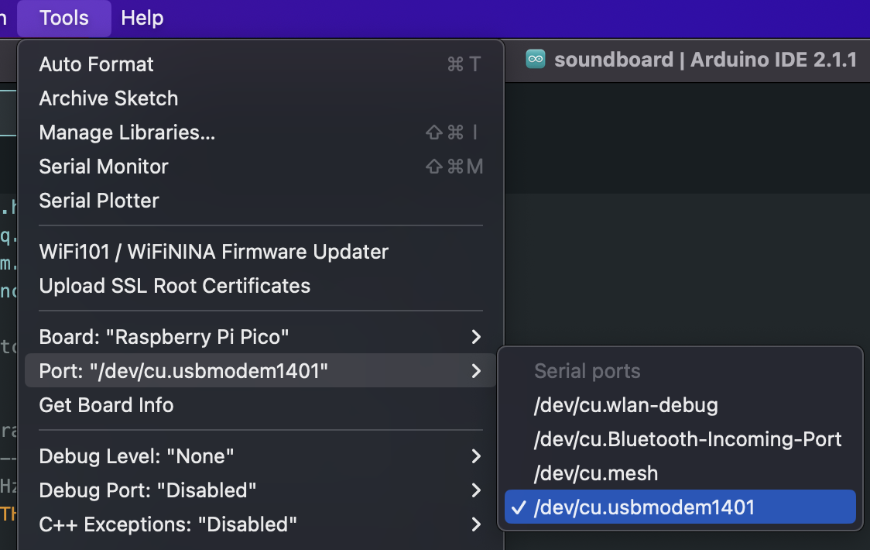

**Final Steps:**

1. Place the Raspberry Pi on the breadboard so that the MicroUSB port is facing **away** from the audio jack and button, and that the pins are placed up to the very top.

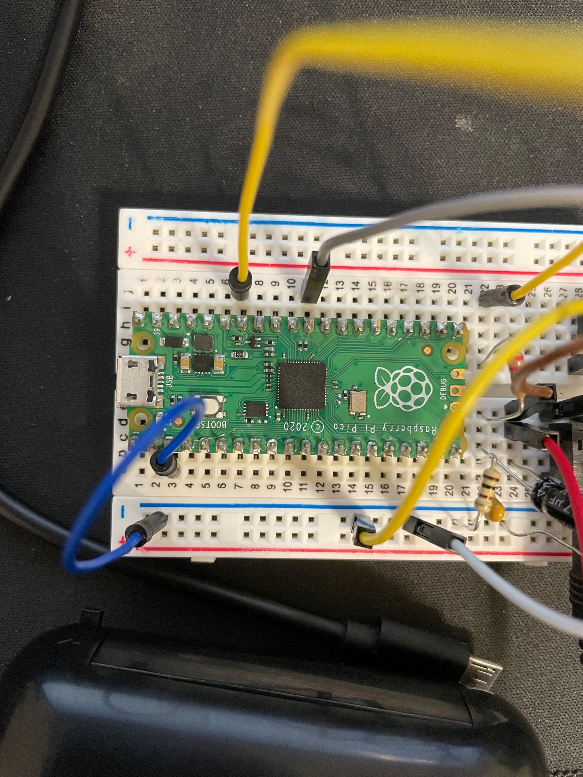

Note: Your Raspberry Pi will connect to the breadboard differently since the soldered pins are on the other side.

1. Connect your speaker to the audio jack. Make sure it's turned on!
2. Click the button!